TO STUDY THE NATURE OF THE PARABOLA y2=4ax a>0

|  |  |
| --- | --- |
|  |  |
|  |  |
|  |  |

MY OBSERVATIONS….

* Parabola is symmetric with respect to x axis
* Parabola opens to the right
* As the value of ‘ a’

TO STUDY THE NATURE OF THE PARABOLA y2=-4ax a>0

|  |  |
| --- | --- |
|  |  |
|  |  |
|  |  |

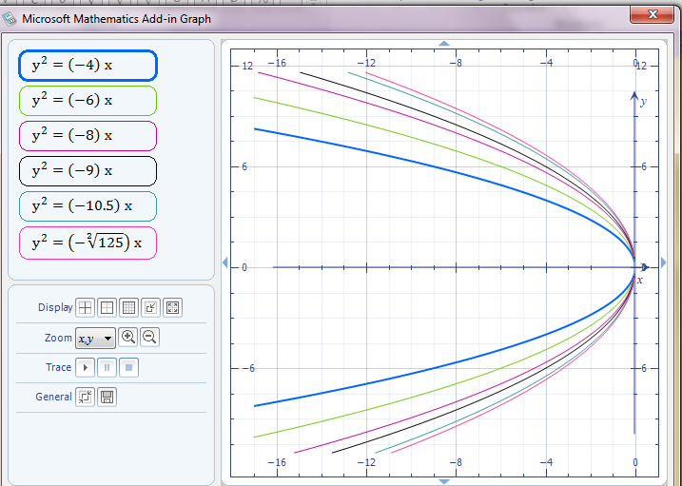

MY OBSERVATIONS……

* Parabola is symmetric with respect to x axis
* Parabola opens to the left
* As the value of a increases the parabola widens.

Comparison of y2=4ax , and of y2=-4ax a > 0

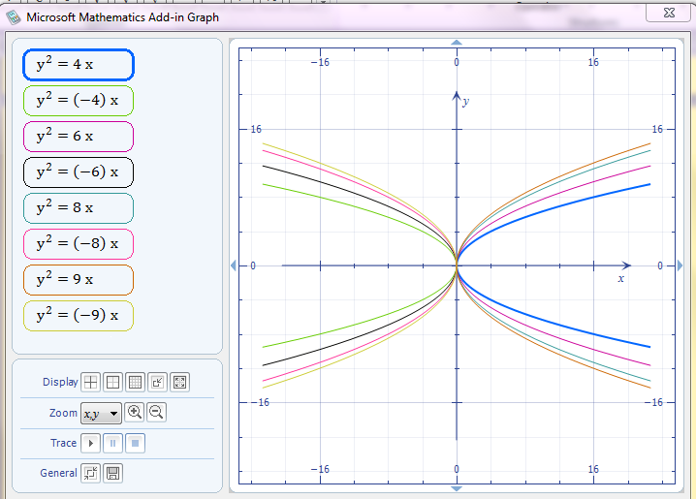

MY OBSERVATIONS…..

* If the equation has a y2 term, parabola is symmetric with respect to x axis
* Parabola opens to the left if the coefficient of x is negative and it opens to the right if the coefficient of x is positive.

TO STUDY THE NATURE OF THE PARABOLA x2=4ay, a>0

|  |  |
| --- | --- |
|  |  |
|  |  |
|  |  |

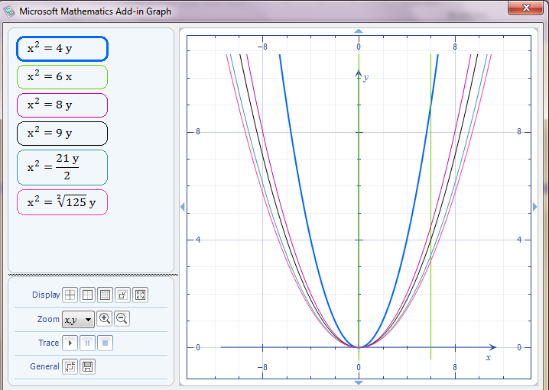

MY OBSERVATIONS…..

* Parabola is symmetric with respect to Y axis
* Parabola opens upwards
* As a increases Parabola widens.

TO STUDY THE NATURE OF THE PARABOLA x2=-4ay, a>0

|  |  |
| --- | --- |
|  |  |
|  |  |
|  |  |

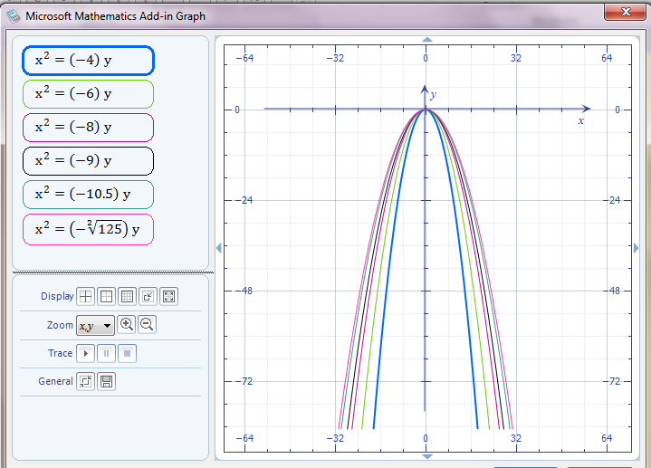

MY OBSERVATIONS…..

* Parabola is symmetric with respect to Y axis
* Parabola open downwards
* As ‘a’ increases, parabola widens

Comparison of x2=4ay and of x2= -4ax a>0

|  |  |
| --- | --- |
|  |  |
|  |  |
|  |  |



MY OBSERVATIONS…..

* If the equation has a x2 term, parabola is symmetric with respect to Y axis
* Parabola opens downwards if the coefficient of y is negative and it opens upwards if the coefficient of y is positive.

TO STUDY THE NATURE OF THE ELLIPSE $\frac{x^{2}}{a^{2}} +\frac{y^{2}}{b^{2}}=1$

$$\frac{x^{2}}{16} +\frac{y^{2}}{9}=1$$

$$\frac{x^{2}}{25} +\frac{y^{2}}{9}=1$$

$$\frac{x^{2}}{81} +\frac{y^{2}}{16}=1$$

$$\frac{x^{2}}{49} +\frac{y^{2}}{9}=1$$

$$\frac{x^{2}}{16} +\frac{y^{2}}{9}=1$$

$$\frac{x^{2}}{81} +\frac{y^{2}}{9}=1$$

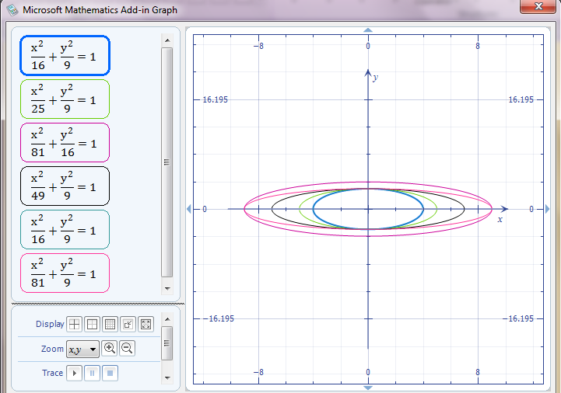

$$\frac{x^{2}}{16} +\frac{y^{2}}{25}=1$$

$$\frac{x^{2}}{16} +\frac{y^{2}}{49}=1$$

$$\frac{x^{2}}{16} +\frac{y^{2}}{36}=1$$

$$\frac{x^{2}}{16} +\frac{y^{2}}{81}=1$$

$$\frac{x^{2}}{16} +\frac{y^{2}}{9}=1$$

$$\frac{x^{2}}{16} +\frac{y^{2}}{9}=1$$

